

### [**[EUROPEAN INTERNATIONAL JOURNAL OF MULTIDISCIPLINARY RESEARCH AND MANAGEMENT STUDIES](https://doi.org/10.1016/j.ssresearch.2021.102620)**](https://doi.org/10.1016/j.ssresearch.2021.102620)

**VOLUME03 ISSUE07**

**DOI:** <https://doi.org/10.55640/eijmrms-03-07-03>Pages: 10-13

**INVATE ENERGY-RESOURCE-SAVING TILLAGE IMPLEMENTS FOR MELON CULTIVATION**

***I. Ismailov***

*Karshi Engineering - Economics Institute, Karshi, Uzbekistan*

***L.Gulomov***

*Karshi Engineering - Economics Institute, Karshi, Uzbekistan*

**ABOUT ARTICLE**

|  |  |
| --- | --- |
| **Key words:** Cucurbits, tillage, main tillage, pre-sowing tillage.  **Received:** 01.07.2023  **Accepted**: 05.07.2023  **Published**: 11.07.2023 | **Abstract:** The analysis of soil preparation for sowing gourds is carried out. Considerable time expenditures on soil preparation lead to moisture losses. In order to eliminate these drawbacks the new combined tillage aggregates are offered, which perform a number of operations on preparing the soil for sowing cucurbitaceous crops in one pass. |

**INTRODUCTION**

Cucurbits are an important component of agricultural production. Cultivation of these crops has a number of peculiarities, especially in soil cultivation. Bahrain crops are cultivated in regions with a warm climate. In many cases, it is necessary to irrigate them [1, 2].

The melon crops are grown mainly on the plains and in the foothills. In the regions of cultivation of melon crops the climatic conditions allow getting up to 3 harvests per year.Considerable time consumption for basic and pre-sowing tillage leads to loss of moisture in a hot climate. For this purpose it is necessary to improve tillage tools for melon cultivation.

Combined tillage tool for cultivation of early ripening varieties of melons is proposed for soil treatment, which performs a number of technological operations in one pass (Fig. 1). During the operation it performs the following technological processes: under the influence of inclined surfaces 4 and chisel 5 of oppositely placed loosening working elements 2 and 3 there is an intensive crumbling of the soil in the zone of melon crops at the depth a. At the same time ploughing foot 6 loosens the soil between the legs of the adjacent pairs of working elements 2 and 3 to a depth a1. Furrow-former 7, installed behind it, forms an irrigation furrow. After that the rotary ripper 8 prepares the soil for sowing [3].

**Top view**

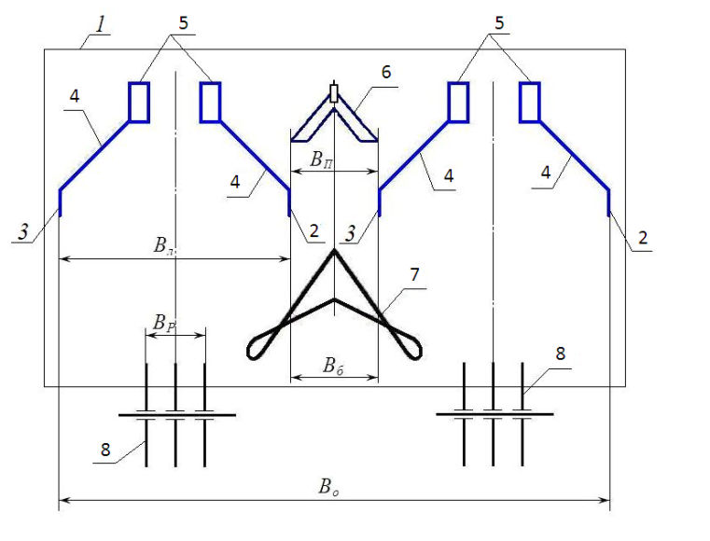

**Back view**

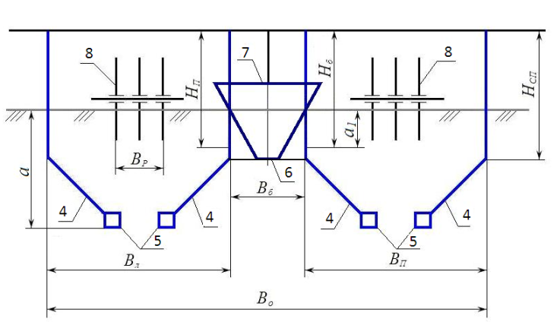

**Figure - 1. Combined tillage tool for melon crops:**

1 - frame; 2 and 3 - right and left-handed loosening inclined working tools;

4 - inclined legs; 5 - chisels; 6 - plane-slashing tine; 7 - furrow former; 8 - rotary rippers.

Bacchus crops are also grown in foothill regions. In this case, there is a need to work on the slopes. Here the soil is prone to erosion, so its cultivation should be carried out with a number of features. A plough for working on slopes is suggested for basic soil cultivation in these conditions (figure 2).

A feature of the plough's design is that a number of bodies are equipped with soil ploughs, and spherical discs are installed behind the bodies. The bodies are also equipped with guide plates.

Ploughing is carried out across the slope. During tillage across the slope the odd-numbered body 2 with working width bк=45,0…52,5 cm penetrating into the soil separates the layer from the bottom of the furrow and interacting with the guide plate 6 turns it by 180o in its own furrow. Then the spherical disk working body 12 removes the top layer from the middle of the wrapped layer and moves the soil to the right to the previous layer. After that even body 3, also with a width of bк penetrating into the soil, separates the layer from the bottom of the furrow and, interacting with the guide plate 7, turns it by 180o in its own furrow. Simultaneously with the turnover of the layer with even body 3, tiller 10 performs subsoil loosening.

Other bodies work in the same way. At the same time on the arable surface in the middle of the odd bodies 2 and 4 a depression is formed, and at the junction of this layer with the previous one water is retained in the furrow limited by the formed ridge. Thus, after the plough passage a stepped bottom of the furrow and ridged surface of the arable land are formed (figure 3). The combination of stepped furrow bottom and ridged surface of arable land promotes water retention and elimination of soil washout after heavy rainfall. All this allows to improve the quality of cultivation and prevents water erosion on slopes [4, 5].

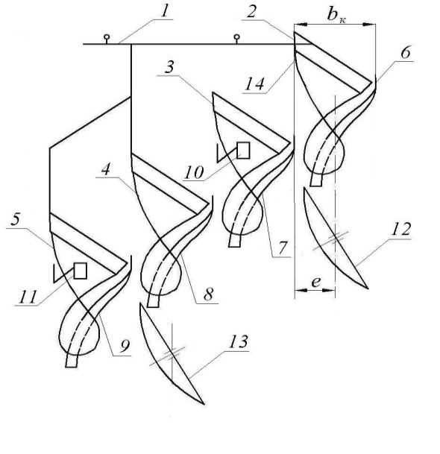

**Figure - 2. Plow for tillage on slopes:**

1 - frame; 2, 3, 4 and 5 - bodies; 6, 7, 8 and 9 - guide plates with working surfaces facing the ploughshare and mouldboard surfaces of bodies; 10, 11 - ploughshares; 12,13 - spherical discs.

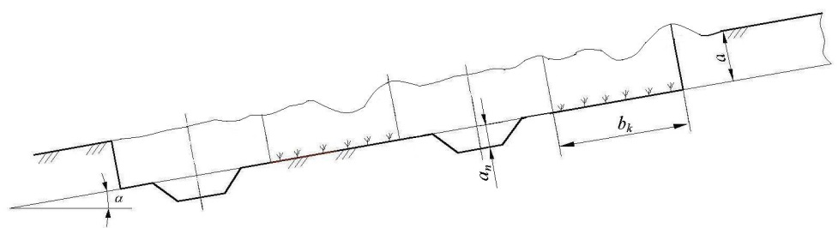

**Figure - 3. Transverse profile of the furrow:**

α-angle of field slope; a-depth of plowing; ap-depth of tillage; bk-width of one plough body.

The use of the proposed resource-saving tillage implements makes it possible to improve the quality of soil preparation for sowing cucurbitaceous crops, reduce the number of machine passes over the field, conserve moisture and reduce soil erosion.

**REFERENCES**

1. RubaiyatSharmin Sultana, Md. MahabuburRahman. Melon crops Improvement through biotechnological techniques for the changing climatic conditions of the 21st century. International Journal of Genetics and Genomics. Vol. 2, No. 3, 2014, pp. 30-41.
2. Aldoshin N.V., Ismailov I.I. Development of soil preparation technology for sowing gourds. Vestnik FGOU VPO Moscow State Agro-engineering University named after V.P. Goryachkin. - №6(88), 2018, с.17...23. -ISSN 1728-7936.
3. Patent № 190971 Russian Federation, IPC A01B 49/02. Soil tillage tool for melon crops / N.V. Aldoshin, F.M. Mamatov, A.A. Manokhina, H.A. Faizullaev, I.I. Ismailov, H.A. Ravshanov; Applicant and patent holder FGBOU VO RGAU - MSKHA named after K.A. Timiryazev №2019111688, 18.04.2019; Publ. 17.07.2019 Bulletin №20.
4. Patent № 190938 Russian Federation, IPK A01B 13/00. Plough for tillage on slopes / N.V. Aldoshin, F.M. Mamatov, A.A. Manokhina, I.I. Ismailov, H.A. Ravshanov, N.Sh. Rashidov; Applicant and patent holder FGBOU VO RGAU - MSKHA named after K.A. Timiryazev № 2019111690, 18.04.2019; publ. 17.07.2019 Bulletin № 20.
5. Bakhadir Mirzaev, Farmon Mamatov Nikolay Aldoshin, Mansur Amonov.Anti-erosion two-stage tillage by ripper. Proceeding of 7th International Conference on Trends in Agricultural Engineering 2019 – Czech University of Life Sciences Prague – Faculty of Engineering, p. 391-395. – ISBN 978-80-213-2953-9.